# Guided Capstone Project Report: Big Mountain Ski Resort

How much increase in ticket price or operational cost cut needs Big Mountain Ski Resort to maintain a profit margin of 9.2% for upcoming season while covering additional cost of $1,540,000 for newly installed chair-lift?

Big Mountain is a ski resort located in Montana and it has spectacular views of Glacier National Park and Flathead National Forest. On average, about 350,000 people visit at the resort to ski or snowboard annually. The resort has 11 lifts, 2 T-bars and 1 magic carpet for service.

Big Mountain Resort has recently updated their service by installing an additional chair lift. So, their operational cost increased by $1.54million. They need a guidance on business strategy either cut operating cost or change the ticket price higher.

Data file was provided from the data manager. Based on the data, Big Mountain Ski Resort ticket price is market average. Data cleaning was performed and also PCA transformation, data scaling and feature correlation were done in the EDA process.

Real insight was gained was after calling a seaborn correlation heatmap on the original data set that identified which features were more positively and negatively associated with ticket price.

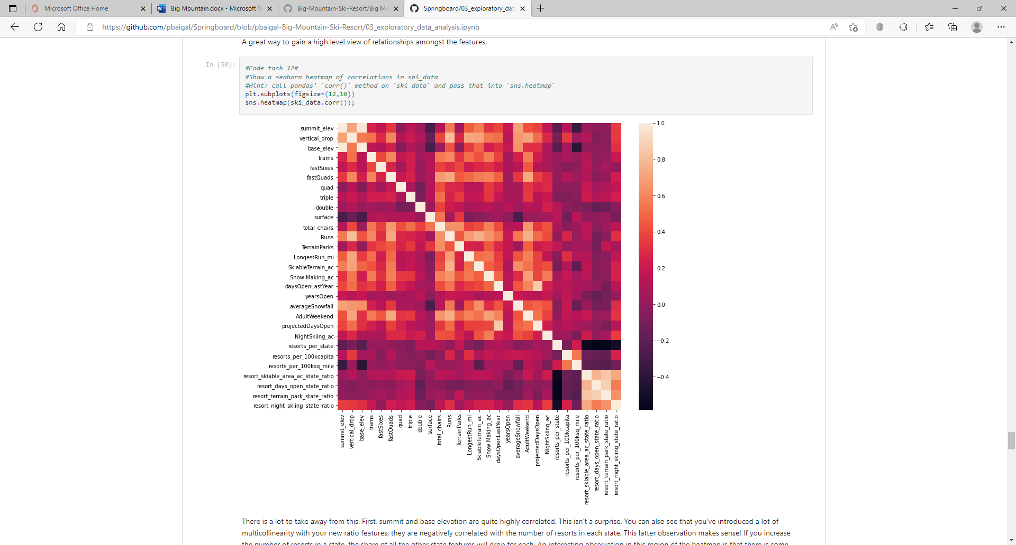It is clear that ticket price is highly correlated with these primary factors: ’fastQuads‘, ’Runs‘, ’vertical_drop’ and ’total_chairs’. Also, ’LongestRun_mi’, ’SkiableTerrain_ac’, ’Snow making_ac’ and ’NightSkiing_ac’ moderately impacted to the ticket price. Two different modelling were performed including Linear and Random Forest. Initial Linear Model using mean prices to examine performance and it is helpful to get the baseline for comparison. While building the model, missing values were imputed with median and mean values. If only Linear model was used to predict ticket price, it would be off by about $9. The initial model was overfitting and it needs to be adjusted by several features including cross validation, the value k was set to eight features to focus on, ’vertical_drop‘, ’Snow making_ac‘, ’total_chairs‘ , ’fastQuads‘, ’Runs‘, ’LongestRun_mi‘, ’trams’ and ’SkiableTerrain_ac‘. Those were fit our initial model assumptions from EDA.

In addition to the linear model, A Random Forest model was used. Missing values were imputed with the median and mean values, as well. The model performance shows the top four features to consider are ‘fastQuads’, ‘Runs’, ‘Snow Making_ac’ and ‘vertical_drop’.

Finally, after testing performance of both the Linear model and Random Forest model, a cross-validation mean absolute error is lower for Random Forest by almost $1 and it reveals less variability, means the Random Forest Regressor works well.

The revenue calculations were in assumption of 350,000 visitors buying the ticket for 5 days. Afterward, made different approaches and business scenarios either cutting costs or increasing revenue from the model can be used to show the changes:

1. Closing up to 10 least used runs. There is no difference, if 1 run is closed. there will be no difference. If 2-3 runs are closed then it reduces support for ticket price, which affects revenue. There is no difference 3 or 4-5 runs are closed. If 6 or more runs are closed, then the ticket price and revenue increasingly drop overall.
2. Adding a run, increasing the vertical drop by 150 feet, and installing an additional chair lift to bring skiers back up without additional snow making coverage.
3. The same as the second scenario, but adding 2 acres of snow making. Second and third scenarios both have the similar result that support a higher ticket price by $1.99 and produce an expected revenue of $3,474,638.
4. Increasing the longest run by 0.2 miles and guaranteeing its snow coverage by adding 4 acres of snow making capability. The result shows no difference on the ticket price and the revenue as well.

Current model only considered adult weekend ticket price. Adult weekday ticket price is equally important. Also, if there are information/data about kids' ticket price could make model better. Some operational cost information including for Runs, snow makers and chair lifting would make business scenarios better and helpful to make reasonable business decision. Additionally, if there are other information/data about revenue making factors such as sales of food and beverages, merchandise sales and equipment rentals would be helpful.